Order Sheet Fill Days

The order sheet fill days value configuration value determines the number of visible usage days that will be shown in the Excel order sheet simulation.

Access order sheet fill days configuration through the main configuration screen from the File|Configuration menu selection.

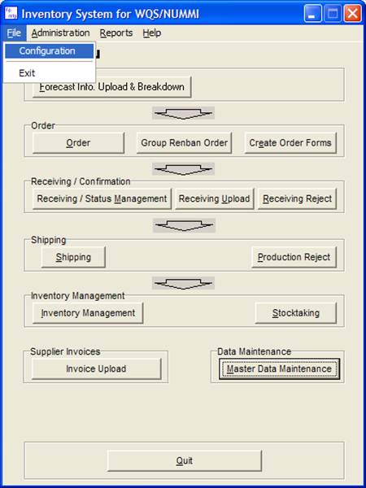

On the system tab, enter the number is fill days required. The maximum value is 50, the old system default is 23. Click OK to accept the new settings.

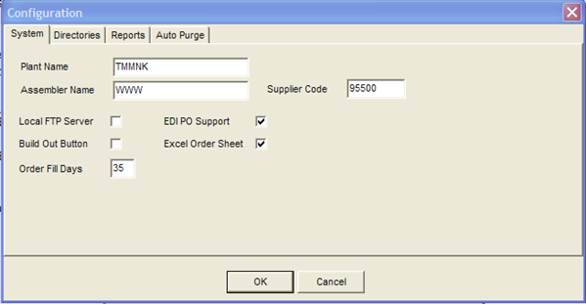

The new number of days will now be visible on the order simulation sheet.

